
Hans Raj Mahila MahaVidyalaya, Jalandhar

7.1.7

DISABLED FRIENDLY, BARRIER FRIENDLY ENVIRONMENT
-POLICY DOCUMENT

POLICY DOCUMENT ON DISABLED FRIENDLY ENVIRONMENT
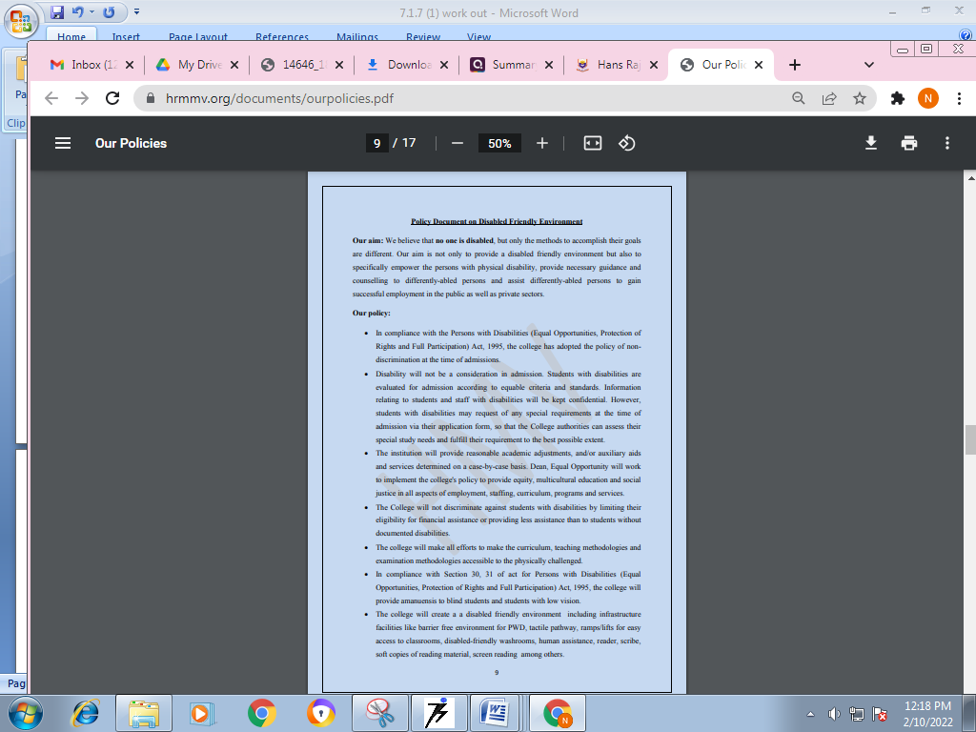
https://www.hrmmv.org/documents/ourpolicies.pdf (PG.9)

Policy Document on Disabled Friendly Environment

Our aim: We believe that no one is disabled, but only the methods to accomplish their goals are different. Our aim is not only to provide a disabled friendly environment but also to specifically empower the persons with physical disability, provide necessary guidance and counselling to differently-abled persons and assist differently-abled persons to gain successful employment in the public as well as private sectors.

Our policy:

- In compliance with the Persons with Disabilities (Equal Opportunities, Protection of Rights and Full Participation) Act, 1995, the college has adopted the policy of non- discrimination at the time of admissions.
- Disability will not be a consideration in admission. Students with disabilities are evaluated for admission according to equable criteria and standards. Information relating to students and staff with disabilities will be kept confidential. However, students with disabilities may request of any special requirements at the time of admission via their application form, so that the College authorities can assess their special study needs and fulfill their requirement to the best possible extent.
- The institution will provide reasonable academic adjustments, and/or auxiliary aids and services determined on a case-by-case basis. Dean, Equal Opportunity will work to implement the college's policy to provide equity, multicultural education and social justice in all aspects of employment, staffing, curriculum, programs and services.
- The College will not discriminate against students with disabilities by limiting their eligibility for financial assistance or providing less assistance than to students without documented disabilities.
- The college will make all efforts to make the curriculum, teaching methodologies and examination methodologies accessible to the physically challenged.
- In compliance with Section 30, 31 of act for Persons with Disabilities (Equal Opportunities, Protection of Rights and Full Participation) Act, 1995, the college will provide amanuensis to blind students and students with low vision.
- The college will create a a disabled friendly environment including infrastructure facilities like barrier free environment for PWD, tactile pathway, ramps/lifts for easy access to classrooms, disabled-friendly washrooms, human assistance, reader, scribe, soft copies of reading material, screen reading among others.

